Images of Error and Corrected Output:
Image of Error Output:
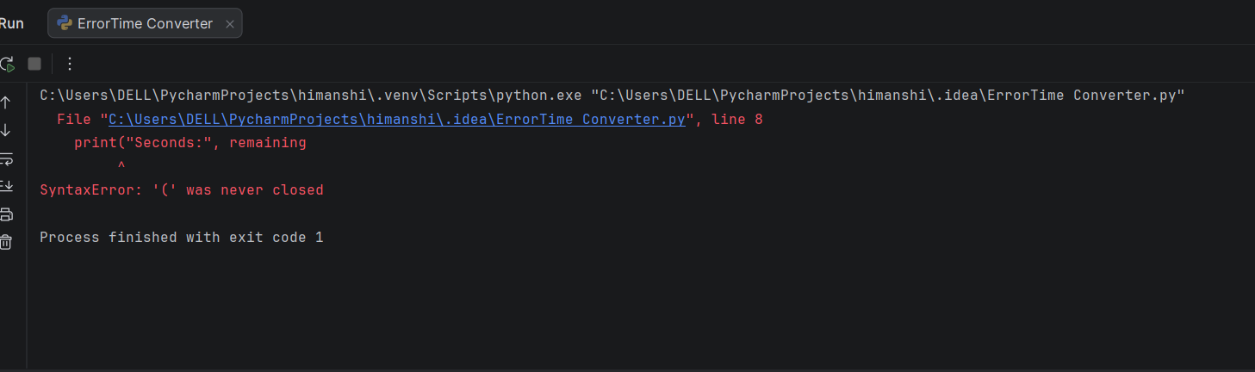
Image of Correct Output:
